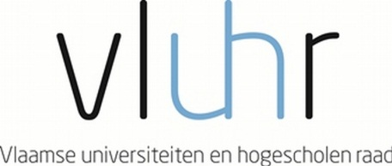

Master Mind Scholarships
Fellowship Programme for Excellent Students
Academic year 2016 – 2017

The Government of Flanders awards up to 45 scholarships to outstanding Master students. The programme aims to promote the internationalization of the Flemish Higher Education, as stated in the Action Plan for Student Mobility, Brains on the Move (September 2013).

The Flemish Host institution applies on behalf of the student.

General eligibility requirements

- The applicant is registered as a full-time student at a higher education institution (hereafter ‘Home Institution’) at the moment of application, and applies to take up a Master degree programme at a higher education institution in Flanders (hereafter ‘Flemish Host Institution’).
- The applicant should have a high standard of academic performance and/or potential. He/she meets all academic entrance criteria, including relevant language requirements, for entering the Master programme in question offered by the Flemish Host Institution.
- The Home Institution of the applicant and the Flemish Host Institution have signed a cooperation agreement.
- Students from all countries can apply. The Home Institution is located outside of Flanders.

Modalities

- The duration of mobility is minimum 1 academic year and maximum the full duration of the master programme. If the student obtains less than 45 ECTS in the first year, then he/she loses the scholarship in the second year.
- The incoming student is awarded a scholarship of maximum €7.500,- per academic year.
- The Flemish Host Institution can ask the applicant for a tuition fee of maximum €105,- per year, which equals the rate of the yearly tuition fee for a student from an underprivileged group.
- The Flemish Host Institution submits the application, on behalf of the student. If a scholarship is awarded to the student, then the Flemish Host Institution is committed to accept the student.
- The program holds for all study areas.
Application

The application needs to be submitted online by the Flemish Host institution.

The deadline for applications at Hasselt University is 1 March 2016.

Selection

A Flemish selection committee awards the scholarships, in cooperation with the Flemish Department of Education and Training.

Timing
- Launch of call: December 2015
- Deadline for application: 31st March 2016
- Selection: April 2016
- Announcement of selection results: May 2016
- Start of mobility: September 2016, for the academic year 2016-2017

Should you have questions about the scholarship programme, you can contact liesbeth.oeyen@uhasselt.be

