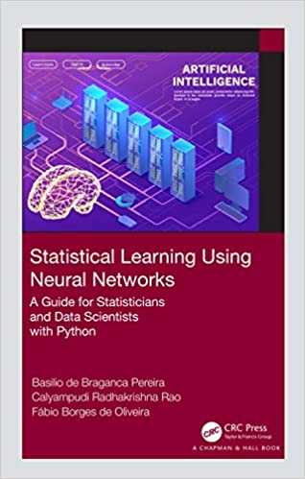

Product details
- Hardcover: 256 pages
- Publisher: Chapman and Hall/CRC; 1 edition (June 5, 2020)
- Language: English
- ISBN-10: 1138364509
- ISBN-13: 978-1138364509
- Product Dimensions: 6.1 x 9.2 inches

About the Authors
Basilio de Bragança Pereira, DIC and PhD (Imperial Collage), is Professor Emeritus of the Federal University of Rio de Janeiro (UFRJ) where he has worked since 1970, in the Institute of Mathematics, Postgraduate School of Engineering (COPPE) and School of Medicine. Associate Professor at the Institute of Mathematics (1970–1989 and 1994–1997), Research Professor at COPPE (1970–present), Titular Professor of Applied Statistics at COPPE (1989–1994, retired), Titular Professor of Biostatistics at the School of Medicine (1998–2015, retired). Since 2018, he is a courtesy researcher at National Laboratory for Scientific Computing (LNCC).
Calyampudi Radhakrishna Rao, PhD and DSc (Cambridge), is Fellow of Royal Society known as C R Rao. He is Professor Emeritus at Pennsylvania State University and Research Professor at the University at Buffalo. Rao was awarded the US National Medal of Science in 2002 and the Guy Medal of the Royal Statistical Society in 1965, Silver, and in 2011, Gold. He is one of the top 10 Indian scientists of all time. He received 38 honorary doctoral degrees from universities in 19 countries. He is well-known for Cramér–Rao inequality, Rao–Blackwellization, Rao distance, Fisher–Rao metric, among other important concepts introduced by him.
Fábio Borges de Oliveira, Dr.-Ing. (TU Darmstadt), is Professor at National Laboratory for Scientific Computing (LNCC) where he gives lectures on cryptography and on artificial intelligence applied to security and privacy for PhD students. He also works in the areas of smart grids, high performance computing, and algorithms. From 1994 to 2002, he worked at Londrina State University, where he provided support to its Computational Mathematics Lab. He was lecturer and taught several subjects. He is an IEEE Senior Member and received the Latin America Distinguished Service Award by IEEE Communications Society in 2018.
Statistical Learning using Neural Networks: A Guide for Statisticians and Data Scientists with Python introduces artificial neural networks starting from the basics and increasingly demanding more effort from readers, who can learn the theory and its applications in statistical methods with concrete Python code examples. It presents a wide range of widely used statistical methodologies, applied in several research areas with Python code examples, which are available online. It is suitable for scientists and developers as well as graduate students.
Key Features:
- Discusses applications in several research areas
- Covers a wide range of widely used statistical methodologies
- Includes Python code examples
- Gives numerous neural network models
This book covers fundamental concepts on Neural Networks including Multivariate Statistics Neural Networks, Regression Neural Network Models, Survival Analysis Networks, Time Series Forecasting Networks, Control Chart Networks, and Statistical Inference Results.
This book is suitable for both teaching and research. It introduces neural networks and is a guide for outsiders of academia working in data mining and artificial intelligence (AI). This book brings together data analysis from statistics to computer science using neural networks.

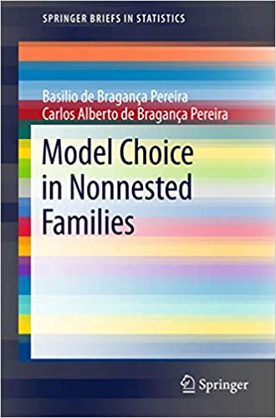

Product details
- Series: SpringerBriefs in Statistics
- Paperback: 108 pages
- Publisher: Springer; 1st ed. 2016 edition (December 30, 2016)
- Language: English
- ISBN-10: 3662537354
- ISBN-13: 978-3662537350
- Product Dimensions: 6.1 x 0.3 x 9.2 inches

Editorial Reviews

Review
“The authors are recognized experts teaching statistics in Brazil universities, and in the book … they present various methods of choosing between competing families of regression models, for instance, exponential versus lognormal models. … The monograph is interesting, innovative, and can serve in search for adequate models in applied statistical analysis.” (Stan Lipovetsky, Technometrics, Vol. 59 (4), November, 2017)

From the Back Cover
This book discusses the problem of model choice when the statistical models are separate, also called nonnested. Chapter 1 provides an introduction, motivating examples and a general overview of the problem. Chapter 2 presents the classical or frequentist approach to the problem as well as several alternative procedures and their properties. Chapter 3 explores the Bayesian approach, the limitations of the classical Bayes factors and the proposed alternative Bayes factors to overcome these limitations. It also discusses a significance Bayesian procedure. Lastly, Chapter 4 examines the pure likelihood approach. Various real-data examples and computer simulations are provided throughout the text.

About the Authors
Basilio de Bragança Pereira is a Professor of Biostatistics and of Applied Statistics at the Federal University of Rio de Janeiro in Brazil.
Carlos Alberto de Bragança Pereira is a Professor of Statistics at the University of Sao Paulo in Brazil.
Read less

